E-Project

Wei-Hsin (Philip) Lin, Tien Nguyen, Yang Yang, Jinjin Tang, Zhi Chao Poh

12/9/2016

## Data Extraction Phase

In the data extraction phase of the project, we look separately at six sources from various locations containing data on the (i) 2016 Election Results; (ii) 2012 Election Results; (iii) 2008 Election Results; (iv) 2004 Election Results; (v) 2010 Census; and (vi) County Location.

For each of the first four datasets, we aim to extract a data frame with the columns (i) state ("state"); (ii) county ("county"); (iii) republican votes ("repVote"); and (iv) democrat votes ("demVote"). For the 2010 Census data, we aim to extract a data frame with the columns (i) state ("state"); (ii) county ("county"); and (iii) 35 other relevant variables described below. For the County Location data, we aim to obtain a data frame with the columns (i) state ("state"); (ii) county ("county"); (iii) longitude ("longitude"); and (iv) latitude ("latitude"). It should be noted that the percentages of votes in each county are not considered in the analysis, and only the votes of each of the two main parties are considered.

Below, we will present a general overview and description of parsing for each dataset before presenting the R code for that segment. Specifics are denoted by comments for code blocks in the code, and it should be noted that certain steps relating to data cleaning, which may not be described in the overview, will be touched on and explained subsequently in the report. The following code defines the parameters defining whether to load the saved pre-existing dataframes into the workspace.

### 2016 Presidential Election Results

Data for the 2016 Presidential Election Results were available as a CSV file with 17 columns - of which we were interested in the columns "votes_dem", "votes_gop", "county_name", "state_abbr" which represented the "demVote", "repVote", "county", and "state" respectively. They were eventually extracted into the final eDF2016 dataframe. The code is as follows:

if (createAllSources) {  
   
 require(readr)  
   
 # Reading the data from the CSV file  
   
 dataURL = "http://www.stat.berkeley.edu/users/nolan/data/voteProject/2016_US_County_Level_Presidential_Results.csv"  
 eDF2016_Raw = read.csv(url(dataURL))  
   
 # Extracting only relevant columns and removing duplicates  
   
 eDF2016_Raw = eDF2016_Raw[c(2:3, 9:10)]  
 eDF2016_Raw = unique(eDF2016_Raw)  
   
 # Removing additional words and punctuation lower-casing county  
   
 eDF2016_Raw$county_name = tolower(eDF2016_Raw$county_name)  
 eDF2016_Raw$county_name = gsub("(county)|(parish)|(city)|([[:punct:]])| ", "", eDF2016_Raw$county_name)  
   
 # Reading and mergin additional state data online to convert abbreviations  
   
 extDataURL = "http://www.fonz.net/blog/wp-content/uploads/2008/04/states.csv"  
 eDF2016_ExtData = read.csv(url(extDataURL))  
 eDF2016_Raw = merge(eDF2016_Raw, eDF2016_ExtData, by.x = "state_abbr", by.y = "Abbreviation")  
   
 # Removing additional words and punctuation lower-casing state  
   
 eDF2016_Raw$State = tolower(eDF2016_Raw$State)  
 eDF2016_Raw$State = gsub("([[:punct:]])|( )", "", eDF2016_Raw$State)  
   
 # Combining repeated cities together   
   
 dup1 = which(duplicated(eDF2016_Raw[, 4:5]) == TRUE)  
 dup2 = which(duplicated(eDF2016_Raw[, 4:5], fromLast = TRUE))  
 for (i in 1:length(dup1)) {  
 eDF2016_Raw[dup1[i], 2:3] = eDF2016_Raw[dup1[i], 2:3] + eDF2016_Raw[dup2[i], 2:3]  
 }  
 eDF2016_Raw = eDF2016_Raw[-dup2, ]  
   
 # Creating the mergeID for subsequent merging and creating the final   
   
 eDF2016_Raw$mergeID = paste(eDF2016_Raw$State, eDF2016_Raw$county_name, sep="")  
 eDF2016 = data.frame(mergeID = eDF2016_Raw$mergeID, state2016 = eDF2016_Raw$State, county2016 = eDF2016_Raw$county_name, repVote2016 = eDF2016_Raw$votes_gop, demVote2016 = eDF2016_Raw$votes_dem)  
 save(eDF2016, file = "eDF2016.rda")  
} else {  
 load("eDF2016.rda")  
}

### 2012 Presidential Election Results

Data for the 2012 Presidential Election Results were available as multiple XML files online for each state, each with a similar URL ending with a different state name. To extract these results, we first created a data frame containing a column of URLs to each of these XML files. For each of these URLs, we then obtained the "state", "county", "demVote", and "repVote" by parsing the respective XML files. The code is as follows:

if (createAllSources) {  
   
 require(XML)  
   
 # Reading the state list from an online text file  
   
 dataURL = "http://www.stat.berkeley.edu/~nolan/data/voteProject/countyVotes2012/stateNames.txt"  
 stateLinksDF = read_delim(dataURL, delim = '')  
 stateLinks = vector(length = length(stateLinksDF$states))  
   
 # Piecing together URL links for each state into stateLinks  
 # Removing alaska as there is no xml file for it  
   
 for (i in 1:length(stateLinks)) {  
 baseURL = "http://www.stat.berkeley.edu/users/nolan/data/voteProject/countyVotes2012/"  
 stateLinks[i] <- paste(baseURL, stateLinksDF$states[i], ".xml", sep = "")  
 }  
 stateLinksDF = data.frame(states = stateLinksDF$states, link = stateLinks, stringsAsFactors = FALSE)  
 stateLinksDF = stateLinksDF[-2, ]  
   
 # Parse each xml file and combine data from all of them  
   
 for(i in 1:nrow(stateLinksDF)) {  
 doc = xmlParse(stateLinksDF[i,2])  
 root = xmlRoot(doc)  
   
 # Parsing out demVote, repVote, county, and state from each xml file  
   
 demVote = xpathSApply(root, '//tr[@class = "party-democrat" or @class = "party-democrat race-winner"]/td[@class = "results-popular"]', xmlValue)  
 demVote = as.integer(gsub("[ ,]","", demVote))  
 repVote = xpathSApply(root, '//tr[@class = "party-republican" or @class = "party-republican race-winner"]/td[@class = "results-popular"]', xmlValue)  
 repVote = as.integer(gsub("[ ,]","", repVote))  
 county = xpathSApply(root, '//tbody/tr/th[@class="results-county"]', xmlValue)  
 county = gsub("[0-9]+[[:punct:]][0-9]+% [Rr]eporting", "", county)  
 state = rep(stateLinksDF[i,1], times = length(demVote))  
   
 # Combining data from each xml file together  
   
 eDF2012_temp = data.frame(state, county, demVote, repVote, stringsAsFactors = FALSE)  
 if (i == 1) {   
 eDF2012_Raw = eDF2012_temp  
 }  
 else {  
 eDF2012_Raw = rbind(eDF2012_Raw, eDF2012_temp)  
 }  
 }  
   
 # Removing additional words and punctuation lower-casing county and state  
 # Replacing saint with st in counties  
   
 eDF2012_Raw$county = tolower(eDF2012_Raw$county)  
 eDF2012_Raw$county = gsub("(county)|(parish)|(city)|([[:punct:]])|( )", "", eDF2012_Raw$county)  
 eDF2012_Raw$state = tolower(eDF2012_Raw$state)  
 eDF2012_Raw$state = gsub("([[:punct:]])|( )", "", eDF2012_Raw$state)  
 eDF2012_Raw$county = gsub("saint", "st", eDF2012_Raw$county)  
   
 # Change county names in 2012 to names used in other datasets for consistency  
 # For eg: saint to st, jeffdavis to jeffersondavis, shannon to oglala,  
 # Brooklyn county (NY) to King, Manhanttan (NY) to new york, Staten Island (NY) to Richmond  
   
 eDF2012_Raw$county = gsub("saint", "st", eDF2012_Raw$county)  
 eDF2012_Raw$county[(eDF2012_Raw$state == 'louisiana' | eDF2012_Raw$state == 'mississippi') & (eDF2012_Raw$county == 'jeffdavis')] = 'jeffersondavis'  
 eDF2012_Raw$county[eDF2012_Raw$state == "southdakota" & eDF2012_Raw$county == "shannon"] = "oglala"  
 eDF2012_Raw$county[(eDF2012_Raw$state == "newyork") & (eDF2012_Raw$county == "brooklyn")] = "kings"  
 eDF2012_Raw$county[(eDF2012_Raw$state == "newyork") & (eDF2012_Raw$county == "manhattan")] = "newyork"  
 eDF2012_Raw$county[(eDF2012_Raw$state == "newyork") & (eDF2012_Raw$county == "statenisland")] = "richmond"  
   
 # Creating the mergeID for subsequent merging and creating the final dataframe  
 eDF2012_Raw["mergeId"] = paste(eDF2012_Raw$state, eDF2012_Raw$county, sep='')  
 eDF2012 = data.frame(mergeID = eDF2012_Raw$mergeId, state2012 = eDF2012_Raw$state, county2012 = eDF2012_Raw$county, repVote2012 = eDF2012_Raw$repVote, demVote2012 = eDF2012_Raw$demVote)  
   
 # Combining repeated cities together   
 dup1 = which(duplicated(eDF2012[, 2:3]) == TRUE)  
 dup2 = which(duplicated(eDF2012[, 2:3], fromLast = TRUE))  
 for (i in 1:length(dup1)) {  
 eDF2012[dup1[i], 4:5] = eDF2012[dup1[i], 4:5] + eDF2012[dup2[i], 4:5]  
 }  
 eDF2012 = eDF2012[-dup2, ]  
 save(eDF2012, file = "eDF2012.rda")  
} else {  
 load("eDF2012.rda")  
}

### 2008 Presidential Election Results

Data for the 2008 Presidential Election Results were available as an excel file with multiple sheets. To extract these results, we read and combined the data from all the individual sheets in the columns "state", "county", "Obama", and "McCain" to obtain the desired columns of "state", "county", "demVote", and "repVote" respectively. The code is as follows:

if (createAllSources) {  
   
 library(readxl)  
   
 # Combining the data from different worksheets in the excel file into an initial dataframe  
   
 eDF2008 = read_excel("countyVotes2008.xlsx", sheet = 2)[1:6]  
 eDF2008$state = rep(state.name[1], nrow(eDF2008))  
 for(i in 3:51) {  
 worksheets = read_excel("countyVotes2008.xlsx", sheet = i)[1:6]  
 worksheets$state <- rep(state.name[i - 1], nrow(worksheets))  
 eDF2008 = rbind(eDF2008, worksheets)  
 }  
 eDF2008 = data.frame(state2008 = eDF2008$state, county2008 = eDF2008$`County `, repVote2008 = eDF2008$`McCain `, demVote2008 = eDF2008$`Obama `,stringsAsFactors = FALSE)  
   
 # Removing additional words and punctuation lower-casing county  
   
 eDF2008$state2008 = tolower(eDF2008$state2008)  
 eDF2008$state2008 = gsub("( )|([[:punct:]])", "", eDF2008$state2008)  
 eDF2008$county2008 = tolower(eDF2008$county2008)  
 eDF2008$county2008 = gsub("( )|([[:punct:]])|(city)|(parish)|(county)", "", eDF2008$county2008)  
   
 # Change county names in 2008 to names used in other datasets for consistency  
 # For eg: saint to st, jeffdavis to jeffersondavis, and shannon to oglala  
 # Brooklyn county (NY) to King, Manhanttan (NY) to new york, Staten Island (NY) to Richmond  
   
 eDF2008$county2008 = gsub("saint", "st", eDF2008$county2008)  
 eDF2008$county2008[(eDF2008$state2008 == "louisiana"| eDF2008$state2008 == "mississippi") & eDF2008$county2008 == "jeffdavis"] <- "jeffersondavis"  
 eDF2008$county2008[eDF2008$state2008 == "southdakota" & eDF2008$county2008 == "shannon"] = "oglala"  
 eDF2008$county2008[eDF2008$state2008 == "montana" & eDF2008$county2008 == "lewisclark"] = "lewisandclark"  
 eDF2008$county2008[(eDF2008$state2008 == "newyork") & (eDF2008$county2008 == "brooklyn")] = "kings"  
 eDF2008$county2008[(eDF2008$state2008 == "newyork") & (eDF2008$county2008 == "manhattan")] = "newyork"  
 eDF2008$county2008[(eDF2008$state2008 == "newyork") & (eDF2008$county2008 == "statenisland")] = "richmond"  
   
 # Creating the mergeID for subsequent merging to creating the final dataframe  
   
 eDF2008$mergeID = paste(eDF2008$state2008, eDF2008$county2008, sep = "")  
   
 # Combining repeated cities together   
   
 dup1 = which(duplicated(eDF2008[, 1:2]) == TRUE)  
 dup2 = which(duplicated(eDF2008[, 1:2], fromLast = TRUE))  
 for (i in 1:length(dup1)) {  
 eDF2008[dup1[i], 3:4] = eDF2008[dup1[i], 3:4] + eDF2008[dup2[i], 3:4]  
 }  
 eDF2008 <- eDF2008[-dup2, ]  
 save(eDF2008, file = "eDF2008.rda")  
} else {  
 load("eDF2008.rda")  
}

### 2004 Presidential Election Results

Data for the 2004 Presidential Election Results were available as a text file with four columns, which were extracted to obtain the desired columns of "state", "county", "demVote", and "repVote". However, since results for virginia state were not included, we had to supplement this original dataset with vote information available on wikipedia for virginia in 2004. The code is as follows:

if (createAllSources) {  
  
 require(RCurl)  
 require(readr)  
   
 # Reading the data for virginia from wikipedia  
   
 url = "https://en.wikipedia.org/wiki/United_States_presidential_election_in_Virginia,_2004"  
 htmlContents = getURL(url)  
 doc = htmlParse(htmlContents)  
 urlTables = readHTMLTable(doc)  
 resultsV_Raw = urlTables[[9]]  
 names(resultsV_Raw) = c("county", "demPer", "demVote", "repPer", "repVote", "otherPer", "otherVote")  
   
 # Parsing out demVote, repVote, and county  
   
 resultsV_County = tolower(resultsV_Raw$county)  
 resultsV_County = tolower(gsub("([Cc]ity)|([Vv]irginia)|( )|[[:punct:]]", "", resultsV_County))  
 resultsV_DemVote = as.numeric(gsub(",", "", resultsV_Raw$demVote))  
 resultsV_RepVote = as.numeric(gsub(",", "", resultsV_Raw$repVote))  
 resultsV = data.frame(state = "virginia", county = resultsV_County, demVote = resultsV_DemVote, repVote = resultsV_RepVote, stringsAsFactors = FALSE)  
   
 # Reading the data for all other states in 2004  
   
 dataURL = "http://www.stat.berkeley.edu/~nolan/data/voteProject/countyVotes2004.txt"  
 #eDF2004_Raw <- read_delim(dataURL, delim = ' ')  
 eDF2004_Raw = read.table(dataURL, sep="", header = TRUE, stringsAsFactors = FALSE)  
 eDF2004_Raw_Split = strsplit(eDF2004_Raw$countyName, ",")  
   
 # Parsing out demVote, repVote, and county  
   
 state = tolower(sapply(eDF2004_Raw_Split, function(x) {x[1]}))  
 state = gsub("( )|([[:punct:]]) ", "", state)  
 county = tolower(sapply(eDF2004_Raw_Split, function(x) {x[2]}))  
 county = gsub("(parish)|(city)|( )|([[:punct:]])", "", county)  
 demVote = eDF2004_Raw$kerryVote  
 repVote = eDF2004_Raw$bushVote  
   
 # Combining 2004 data for virginia with the rest  
   
 eDF2004 = data.frame(state, county, demVote, repVote, stringsAsFactors = FALSE)  
 eDF2004 = rbind(eDF2004,resultsV)  
   
 # Change county names in 2004 to names used in other datasets for consistency  
 # For eg: shannon to oglala, washington to districtofcolumbia, dade to miamidade, etc  
   
 eDF2004$county[eDF2004$state == "southdakota" & eDF2004$county == "shannon"] <- "oglala"  
 eDF2004$county[eDF2004$county == "washington" & eDF2004$state == "districtofcolumbia"] <- "districtofcolumbia"  
 eDF2004$county[eDF2004$county == "dade" & eDF2004$state == "florida"] <- "miamidade"  
 eDF2004$county[eDF2004$county == "beach" & eDF2004$state == "virginia"] <- "virginiabeach"  
   
 # Creating the mergeID for subsequent merging and creating the final   
   
 eDF2004["mergeID"] = paste(eDF2004$state, eDF2004$county, sep = "")  
 eDF2004 = data.frame(mergeID = eDF2004$mergeID, state2004 = eDF2004$state, county2004 = eDF2004$county, repVote2004 = eDF2004$repVote, demVote2004 = eDF2004$demVote)  
   
 # Combining repeated cities together   
   
 dup1 <- which(duplicated(eDF2004[, 2:3]) == TRUE)  
 dup2 <- which(duplicated(eDF2004[, 2:3], fromLast = TRUE))  
 for (i in 1:length(dup1)) {  
 eDF2004[dup1[i], 4:5] <- eDF2004[dup1[i], 4:5] + eDF2004[dup2[i], 4:5]  
 }  
 eDF2004 <- eDF2004[-dup2, ]  
 save(eDF2004, file = "eDF2004.rda")  
} else {  
 load("eDF2004.rda")  
}

### 2010 Census Data

Data for the 2010 Census was available as three separate CSV files. To obtain a dataframe for only certain selected variables, we simply extracted relevant columns out from each CSV file and merged them together to obtain a final complete dataframe for the census data.

The selection of variables to be used in building out prediction model were manually decided upon. As a voter's background would possibly have the largest influence on his decision at the polls, we decided to focus on factors pertaining to his social identity. This included his economic class - career, income levels, etc - gender, marital status, and race. The code is as follows:

if (createAllSources) {  
   
 require(readr)  
 require(dplyr)  
   
 # Reading data from the BP01.csv  
   
 dataURL = "http://www.stat.berkeley.edu/users/nolan/data/voteProject/census2010/B01003.csv"  
 B01 = read.csv(dataURL, sep = ',', stringsAsFactors = FALSE)  
   
 # Making separate dataframe corresponding to the pop.group id  
   
 B01 = B01[,-c(1,2,5,7)]  
 B011 = B01[B01$POPGROUP.id==1, ]  
 B012 = B01[B01$POPGROUP.id==2, ]  
 B014 = B01[B01$POPGROUP.id==4, ]  
   
 # Merge the above dataframe to have data for each county in each row  
   
 merge1 = merge(B011, B012, by = 'GEO.display.label', all.x = TRUE)   
 merge2 = merge(merge1, B014, by = 'GEO.display.label', all.x = TRUE)  
   
 # Take out the pop.group id and rename the columns  
   
 B01 = merge2[ ,-c(2,4,6)]  
 names(B01) = c("county", "TotalPop", "WhiteAlone", "Black-AfAlone")  
   
 # Reading data from DP02  
   
 dataURL = "http://www.stat.berkeley.edu/users/nolan/data/voteProject/census2010/DP02.csv"  
 DP02 = read.csv(dataURL, sep = ',',stringsAsFactors = FALSE)  
   
 # Choosing the variables by column names  
 # Subsetting the dataframe with selected columns and rename them  
   
 selectedCols1 = c("GEO.display.label","HC01_VC03", "HC03_VC09","HC03_VC11","HC01_VC20","HC03_VC36","HC03_VC38","HC03_VC39","HC03_VC40","HC03_VC52","HC03_VC85","HC03_VC86","HC03_VC87","HC03_VC88","HC03_VC89","HC03_VC90","HC03_VC91","HC01_VC138","HC03_VC167","HC03_VC168")  
 DP02 = DP02[ , selectedCols1]  
 names(DP02) = c("county","TotalHouseholds", "PerMaleHouseholder", "PerFemaleHouseholder", "AveHouseSize", "PerNeverMarried", "PerSeparated", "PerWidowed", "PerDivorced", "PerUnmarriedWomen", "Per<9thGrade", "Per9th-12th", "PerhsGrad", "PersomeCollege", "PerAssociate", "PerBachelor", "PerGrad-Prof", "ForeignBornPop", "PerEngOnlySpeaker", "PerOtherLanguages")  
   
 # Reading data from DP03  
   
 dataURL = "http://www.stat.berkeley.edu/users/nolan/data/voteProject/census2010/DP03.csv"  
 DP03 = read.csv(dataURL, sep = ',', stringsAsFactors = FALSE)  
   
 # Choosing the variables by column names  
 # Subsetting the dataframe with selected columns and rename them  
   
 selectedCols2 = c("GEO.display.label","HC03_VC05", "HC03_VC13","HC03_VC18","HC03_VC41","HC03_VC42","HC03_VC75","HC03_VC78","HC03_VC82","HC01_VC85","HC03_VC92","HC03_VC95","HC03_VC166")  
 DP03 = DP03[ , selectedCols2]  
 names(DP03) = c("county", "PerInLaborForce", "PerUnemployed", "PerEmployed", "PerInManageBusSciField", "PerServiceField", "PerInc<10k", "PerInc25-34k", "PerInc100-149k", "MedInc", "PerWithRetirementInc", "PerWithSSIInc", "PerIncBelowPovertyLevel")  
   
 # Merging and organizing data  
 # Rename Do<f1>a Ana County because it has special character  
   
 merge3 = merge(DP02, DP03, by = "county")  
 CensusDF2010 = merge(B01, merge3, by = "county")  
 CensusDF2010$county[794] = "Dona Ana, New Mexico"  
   
 # Split the states and counties into 2 separate columns  
 # Take out county, parish, city all punctuation, and space in the county, state name  
   
 dataSplit = strsplit(CensusDF2010$county, ",")  
 county = tolower(sapply(dataSplit, function(x) {x[1]}))  
 county = gsub("(county)|(city)|(parish)|([[:punct:]])|( )", "", county)  
 state = tolower(sapply(dataSplit, function(x) {x[2]}))  
 state = gsub("(county)|(parish)|([[:punct:]])|( )", "", state)  
   
 # Merge states counties and data into a single dataframe for 2010  
 # Change county names in the data to names used in other datasets for consistency  
 # For eg: shannon to oglala,   
   
 CensusDF2010 = data.frame(state, county, CensusDF2010[ ,-1], stringsAsFactors = FALSE)  
 CensusDF2010$county[CensusDF2010$state == "southdakota" & CensusDF2010$county == "shannon"] = "oglala"  
   
 # Combining repeated counties (Having dropped city)  
 # Create mergeID for subsequent merging  
   
 CensusDF2010 = distinct(CensusDF2010, state, county, .keep_all = TRUE)  
 CensusDF2010["mergeID"] = paste(CensusDF2010$state, CensusDF2010$county, sep='')  
 save(CensusDF2010, file = "CensusDF2010.rda")  
} else {  
 load("CensusDF2010.rda")  
}

### 2016 County Location Data

Data for each county's location in the USA was available as a GML file online. We specifically extracted the values pertaining to the state, county, longitude, and latitude at each GML countynode. In particular, the state vector was harder to create due to its single appearance at each state node (containing multiple county notes), and was created by replacing a county vector by its respective state at each county. The code is as follows:

if (createAllSources) {  
  
 require(dplyr)  
 require(XML)  
   
 # Reading the data from the GML file  
   
 gml = xmlParse("http://www.stat.berkeley.edu/~nolan/data/voteProject/counties.gml")  
 gmlroot = xmlRoot(gml)  
   
 # Define a function to produce the correct state vector that matches the counties  
   
 getStateFromState = function(x) {  
 pathName = paste('//county[../gml:name/text()="', x, '"]/gml:name', sep='')  
 results = xpathSApply(gmlroot, pathName, xmlValue)  
 results[] = x  
 return (results)  
 }  
   
 # Parsing the state, county, latitude, and longitude  
 # Convert longitude and latitude to their proper format  
   
 stateNames = xpathSApply(gmlroot, '//state/gml:name', xmlValue)  
 stateNames = sapply(stateNames, getStateFromState)  
 stateNames = tolower(unlist(stateNames))  
 stateNames = gsub(' |\n |([[:punct:]])', '', stateNames)  
 countyNames = xpathSApply(gmlroot, '//county/gml:name', xmlValue)  
 countyNames = gsub("(county)|(parish)|(city)|([[:punct:]])| |\n", "", tolower(countyNames))  
 countylong = xpathSApply(gmlroot, '//gml:X', xmlValue)  
 countylong = gsub(' |\n', '', countylong)  
 countylong = as.numeric(countylong)/1000000  
 countylat = xpathSApply(gmlroot, '//gml:Y', xmlValue)  
 countylat = gsub(' |\n', '', countylat)  
 countylat = as.numeric(countylat)/1000000  
   
 # Creating the dataLoc dataframe from state, county, longitude, latitude  
 # Combining repeated counties (Having dropped city)  
 # Change county names in the data for consistency (eg shannon to oglala)  
   
 dataLoc = data.frame(state = as.character(stateNames), county = as.character(countyNames), long = as.numeric(countylong), lat = as.numeric(countylat), stringsAsFactors = FALSE)  
 dataLoc = distinct(dataLoc, state, county, .keep_all = TRUE)  
 dataLoc$county[dataLoc$state == "southdakota" & dataLoc$county == "shannon"] = "oglala"  
   
 # Creating the mergeID for subsequent merging and creating the final dataframe  
   
 dataLoc["mergeId"] = paste(dataLoc$state, dataLoc$county, sep='')  
 dataLoc = data.frame(mergeID = dataLoc$mergeId, stateLoc = dataLoc$state, countyLoc = dataLoc$county, longitude = dataLoc$long, latitude = dataLoc$lat)  
   
 save(dataLoc, file = "dataLoc.rda")  
} else {  
 load("dataLoc.rda")  
}

## Data Cleaning Phase

In the data extraction phase of the project, we will examine a series of issues that arose as we performed our preliminary data extraction, and explain how each was resolved to obtain a cleaned individual dataframes that could be merged together without issue and used for subsequent analysis and mapping. These issues are mentioned in the following paragraphs.

### Creating a Merge ID (All Data)

To facilitate the subsequent merging process in which all six dataframes were merged together on unique pairs of (state, county) indices, we created a temporary column named "mergeID" that consisted of the state and county concatenated together in a single string. This would greatly simplify the merging process subsequently, and was applied to all data as all would have to be eventually merged together.

### Truncating County Names (All Data)

It was observed that different data sources referred to the same county differently - there were those with an additional "parish", "county", "city", dot, space, or dash to the term, as well as a mix of lower and upper case letters in the name. This would interfere with the merging process as two counties would be considered distinct when they were effectively the same entity. Therefore, we removed all the terms mentioned from all county names and converted them to lowercase in all data sets in this data cleaning phase. Note that the "city" suffix was sometimes used to differentiate between a county and its city - but this was removed as explained in the subsequent section.

### Combining "Repeated" County Votes (2004 & 2008 & 2012 & 2016 Data)

We noticed that there were certain states with counties and their corresponding cities having the same name (following the removal of the "city" suffix). Maryland state, for instance, then had both Baltimore (County) and Baltimore (City). However, we combined these two together based on the fact that Baltimore County and Baltimore City historically used to be the same municipal region, and hence decided to combine the votes from both Baltimore (City) and Baltimore (County) into just Baltimore (County). This process was also repeated for all similar cases in all states across all election result data sets.

### Dropping "Repeated" County Information (Location & Census Data)

As a continuation of the issue highlighted in the previous paragraph, we noted that the combination of Baltimore (City) and Baltimore (County), for instance, into Baltimore (City), was not essential for location and census data as either value of one could be used as an approximate of the other since both cities and their counties were close in proximity. Therefore, we simply dropped either row for the location and census data when such repetitions were observed.

### Modifying County Names (2008 & 2012 Data)

Data from the 2008 and 2012 Presidential Election Results seemed to contain county names with "saint", while the rest of the data sources contained "st" for the same term. To standardize our county name for the purpose of merging on a unique identifier in the subsequent phase, we proceeded to replace all "saint" occurrences with "st" in these two dataframes.

### Modifying State Names (2016 Data)

At first glance it was evident that the 2016 Presidential Election Results provided the state as a two letter abbreviation, which would definitely not match well with state names from all other datasets. To solve this problem, we imported a table from another online resource with both the state names and state abbreviations and used this table to convert all abbreviations to the unabridged state names.

### Dropping Duplicated Rows for Alaska (2016 Data)

Upon examination of the imported data for the 2016 Presidential Election Results, it was clear that there were multiple row entries for Alaska, which all had the same values for the vote counts. We thus dropped such duplicated rows for Alaska and only kept one entry.

### Transforming Location Coordinates (Location Data)

Upon plotting of the counties on the USA map according to their longitude and latitude coordinates, it became apparent that the coordinates did not match the typical input coordinates required - with eight to nine digits instead of just two or three. To solve this issue, we simply divided the raw coordinates by 1 million to obtain a plot that gave county locations neatly within the USA map.

### Verification of Data Cleaning - (i) Checking States & Counties

Before merging all data frames together, we do some check points to see if there are any potential mistakes that we have while reading the data from different sources. First of all, we count the number of unique states and total number of counties in each data frame to see if it is consistent. Secondly, we check the number of NAs values in each data frame. After checking the number of NAs, we see that the data for Black and African American population was missing half of the values, so we decided to drop that columns from the Census data before merging all the data frame together.

# Check number of unique states in each data frame  
  
numStates2004 = length(unique(eDF2004$state2004))  
numStates2008 = length(unique(eDF2008$state2008))  
numStates2012 = length(unique(eDF2012$state2012))  
numStates2016 = length(unique(eDF2016$state2016))  
numStates2010 = length(unique(CensusDF2010$state))  
numStatesLoc = length(unique(dataLoc$stateLoc))  
  
# Check the number of counties in each data frame  
  
numCounty2004 <- nrow(eDF2004)  
numCounty2008 <- nrow(eDF2008)  
numCounty2012 <- nrow(eDF2012)  
numCounty2016 <- nrow(eDF2016)  
numCountyLoc <- nrow(dataLoc)  
numCounty2010 <- nrow(CensusDF2010)  
  
# Check number of NAs   
  
numNA2004 <- sum(is.na(eDF2004))  
numNA2008 <- sum(is.na(eDF2008))  
numNA2012 <- sum(is.na(eDF2012))  
numNA2016 <- sum(is.na(eDF2016))  
numNALoc <- sum(is.na(dataLoc))  
#Taking off the Black and African American Popoulation  
CensusDF2010 = CensusDF2010[,-5]  
numNA2010 <- sum(is.na(CensusDF2010))  
  
summary = matrix(c(numStates2004, numStates2008, numStates2012, numStates2016, numStates2010, numStatesLoc, numCounty2004, numCounty2008, numCounty2012, numCounty2016, numCounty2010, numCountyLoc, numNA2004, numNA2008, numNA2012, numNA2016, numNA2010, numNALoc), byrow = FALSE, nrow = 6, dimnames = list(c("2004", "2008", "2012", "2016", "2010", "Location"), c("numStates", "numCounties", "numNAs")))  
summary

## numStates numCounties numNAs  
## 2004 49 3102 0  
## 2008 50 3108 5  
## 2012 50 3106 0  
## 2016 51 3107 0  
## 2010 51 3132 3  
## Location 51 3133 0

### Verification of Data Cleaning - (ii) Checking County Locations

In order to check the longitude and latitude of all counties and ensure they were properly improrted from the online source, we made a preliminary plot of all the counties on the map, which is depicted as follows:

library(ggplot2)  
  
#Plotting all counties using the coordinates source  
  
mapstate = map_data("state")  
map = ggplot() + ggtitle("Plotting the Counties")  
map + geom_polygon(data = mapstate, aes(x=long, y=lat,group = group), colour="grey50", fill = "white") + geom_jitter(data = dataLoc, aes(x = longitude, y = latitude), size = 0.3)

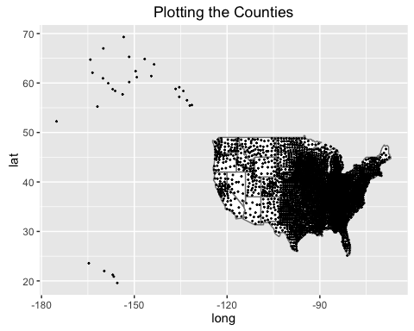

From the first map above, we see that Alaska and Hawaii are included in the map at far-away locations from the center of the map. However, since we are not including these two states in our study, we will drop them and replot the map below.

mapLoc = dataLoc[-c(68:92, 542:546),]  
map = ggplot() + ggtitle("Plotting the Counties without Alaska & Hawaii")  
map + geom_polygon(data = mapstate, aes(x=long, y=lat,group = group), colour="grey50", fill = "white") + geom_jitter(data = mapLoc, aes(x = longitude, y = latitude), size = 0.3)

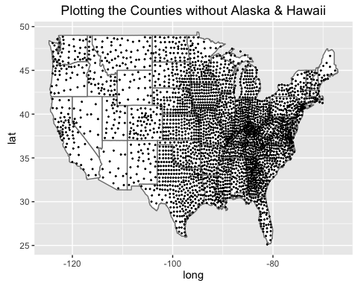

As we see that this second map excluding Alaska and Hawaii has all points are plotted within border of the US map, it is clear that the location coordinates are properly imported.

## Data Merging Phase

In the data merging phase of the project, we then proceed to merge all the six individually obtained and cleaned dataframes into a single complete dataframe that contains the state, county, repVote and demVote for all four elections, longitude and latitude, and all 35 variables for each county obtained in the 2010 Census Data.

This merging process was done two dataframes at a time, merging on the commonly named "mergeID" column, and done with a union for all elections data sets, but with a outer join for location and census data. This was because only the location and census data was needed for the available counties. It would then be possible to check if the cleaning was sufficient by generally observing if the merged complete dataframe had the same number of rows as its constituent dataframes, as the desired merging process would not produce additional rows (presumably with NA values in certain columns).

### Merging All Dataframes

if (createAllSources) {  
 # Merging each dataset together two at a time  
   
 eDF = merge(eDF2016, eDF2012, by = "mergeID", all = TRUE)  
 eDF = merge(eDF, eDF2008, by = "mergeID", all = TRUE)  
 eDF = merge(eDF, eDF2004, by = "mergeID", all = TRUE)  
 eDF = merge(eDF, dataLoc, by = "mergeID", all.x = TRUE)  
 eDF = merge(eDF, CensusDF2010, by = "mergeID", all.x = TRUE)  
 eDF = eDF[-c(3108:3109), -c(1,6,7,10,11,14,15,18,19,22,23)]  
   
 #Supplement missing information from original sources  
 #Location coordinates for Broomfield County in Colorado  
 eDF$longitude[224] = -105.0867  
 eDF$latitude[224] = 39.9205  
   
 #Number of votes for District of Columnbia in 2008 Election  
 eDF$repVote2008[292] = 17367  
 eDF$demVote2008[292] = 254800  
   
 save(eDF, file = "eDF.rda")  
} else {  
 load("eDF.rda")  
}

## EDA and Maps Making (by Jinjin Tang)

require(maps)  
require(ggplot2)  
require(dplyr)

## Loading required package: dplyr

##   
## Attaching package: 'dplyr'

## The following objects are masked from 'package:stats':  
##   
## filter, lag

## The following objects are masked from 'package:base':  
##   
## intersect, setdiff, setequal, union

2016 Election Map

eDF1 <- data.frame(mergeID = paste(eDF$state2016, eDF$county2016, sep = ""), eDF)  
eDFmap=eDF1[c(-519:-522),c("repVote2016", "demVote2016","TotalPop", "longitude", "latitude")]  
eDFmap$propRep_2016=eDFmap$repVote2016/(eDFmap$repVote2016+eDFmap$demVote2016)  
statemap = map_data("state")  
  
blanktheme=theme(axis.line=element_blank(),  
 axis.text.x=element_blank(),  
 axis.text.y=element_blank(),  
 axis.ticks=element_blank(),  
 axis.title.x=element_blank(),  
 axis.title.y=element_blank(),  
 panel.grid.major=element_blank(),  
 panel.grid.minor=element_blank())  
   
ggplot()+  
 geom_polygon(data=statemap,aes(x=long, y=lat, group=group), colour="grey50", fill="white") +  
 geom_point(data=eDFmap,shape=21, aes(x=longitude, y=latitude, size=TotalPop/1000000, fill=propRep_2016), alpha=0.5, color="grey50", na.rm = TRUE)+   
 scale_fill_gradientn("Proportion of Republican Voters",colours=c("blue", "white", "red"))+  
 scale_size("Total Population in Millions",range=c(1,10))+  
 blanktheme+  
 ggtitle("2016 Election Results By County")+  
 coord_fixed(1.3)

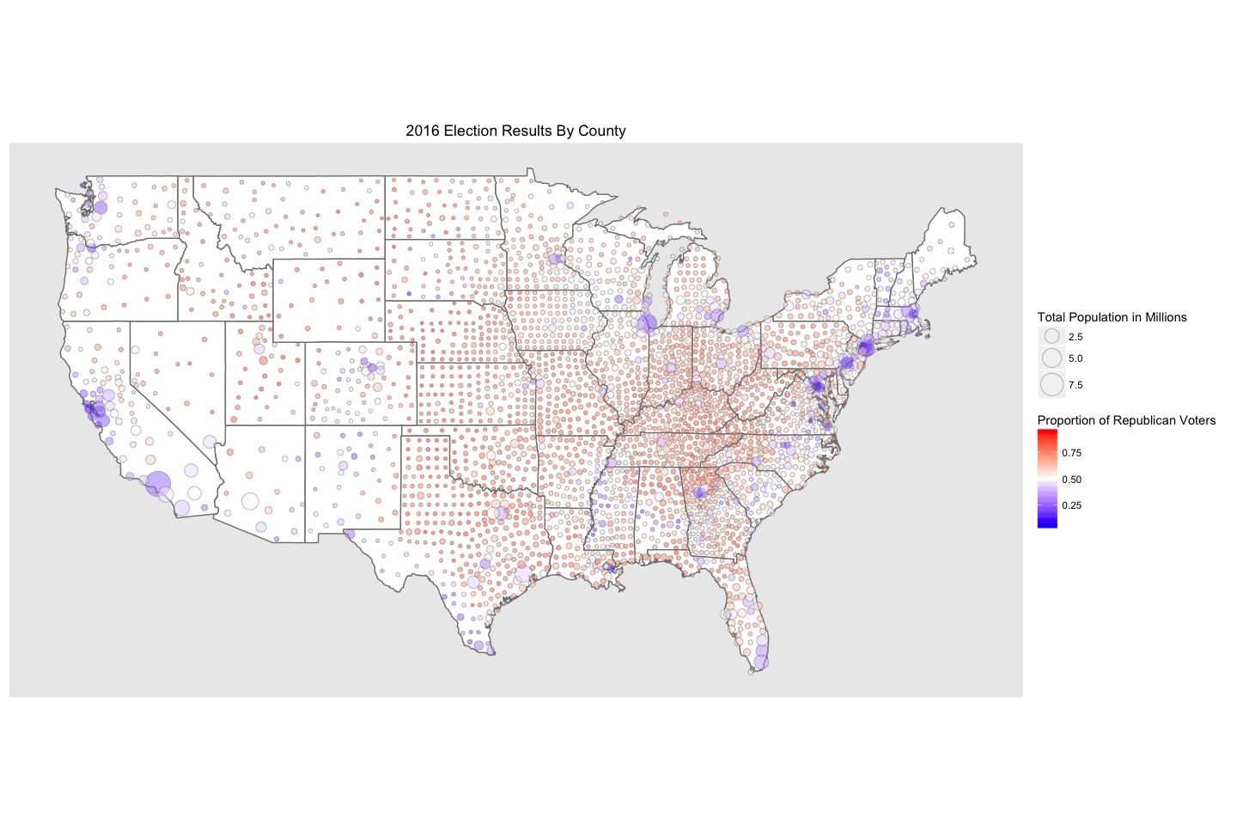

How has the number of votes changed in the past 4 elections?

totalVotes=data.frame(Year=rep(c(2004,2008,2012,2016),2) ,   
 Political_Party=rep(c("Republican", "Democrat"), each=4),  
 Votes = c(  
 sum(eDF1$repVote2004, na.rm = TRUE),   
 sum(eDF1$repVote2008, na.rm = TRUE),   
 sum(eDF1$repVote2012, na.rm = TRUE),   
 sum(eDF1$repVote2016, na.rm = TRUE),   
 sum(eDF1$demVote2004, na.rm = TRUE),   
 sum(eDF1$demVote2008, na.rm = TRUE),   
 sum(eDF1$demVote2012, na.rm = TRUE),   
 sum(eDF1$demVote2016, na.rm = TRUE)))   
  
ggplot(data=totalVotes)+  
 geom_line(aes(x=Year, y=Votes/1000000, color=Political_Party))+  
 scale_y_continuous("Number of Votes in Millions")+  
 geom_vline(xintercept=2004, linetype="longdash")+  
 geom_text(aes(x=2003.5, label="Bush Victory", y=62), angle=90)+  
 geom_vline(xintercept=2008, linetype="longdash")+  
 geom_text(aes(x=2007.5, label="Obama Victory", y=62), angle=90)+  
 geom_vline(xintercept=2012, linetype="longdash")+  
 geom_text(aes(x=2011.5, label="Obama Victory", y=64), angle=90)+  
 geom_vline(xintercept=2016, linetype="longdash")+  
 geom_text(aes(x=2015.5, label="Trump Victory", y=63), angle=90)+  
 scale_color_manual("Political Party", values=c("blue","red"))

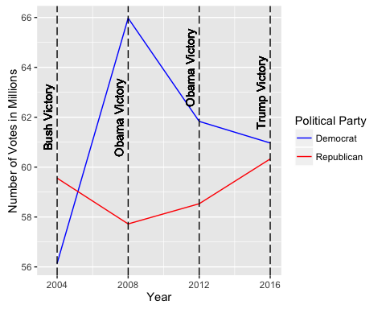

How have counties changed their voting patterns?

countiesmap=map_data("county")  
countiesmap$region = gsub(" ", "", countiesmap$region)  
countiesmap$mergeID=paste(countiesmap$region, countiesmap$subregion, sep='')  
counties_base=ggplot(data=countiesmap,aes(x=long, y=lat, group=group))+geom_polygon(colour="black", fill=NA)  
#counties_base  
  
eDFvoting=eDF1[c(-519:-522),c("repVote2016", "demVote2016","repVote2012", "demVote2012", "repVote2008", "demVote2008", "repVote2004", "demVote2004", "longitude", "latitude", "mergeID")]  
  
eDFvotingmerged=inner_join(countiesmap, eDFvoting, by="mergeID")

## Warning in inner_join_impl(x, y, by$x, by$y, suffix$x, suffix$y): joining  
## character vector and factor, coercing into character vector

eDFvotingmerged$repWin2016=eDFvotingmerged$repVote2016>eDFvotingmerged$demVote2016  
eDFvotingmerged$repWin2012=eDFvotingmerged$repVote2012>eDFvotingmerged$demVote2012  
eDFvotingmerged$repWin2008=eDFvotingmerged$repVote2016>eDFvotingmerged$demVote2008  
eDFvotingmerged$repWin2004=eDFvotingmerged$repVote2016>eDFvotingmerged$demVote2004  
eDFvotingmerged$totalrepWin=rowSums(eDFvotingmerged[,18:21])  
  
counties_base+  
 geom_polygon(data = eDFvotingmerged, aes(x=long, y=lat, group=group, fill=totalrepWin), colour="grey50")+  
 scale_fill_gradientn("Number of Republican Victories", colours=c("blue", "white", "red"))+  
 ggtitle("Have Counties Changed Their Voting Patterns in the Past 4 Elections?")+  
 blanktheme+  
 coord_fixed(1.3)

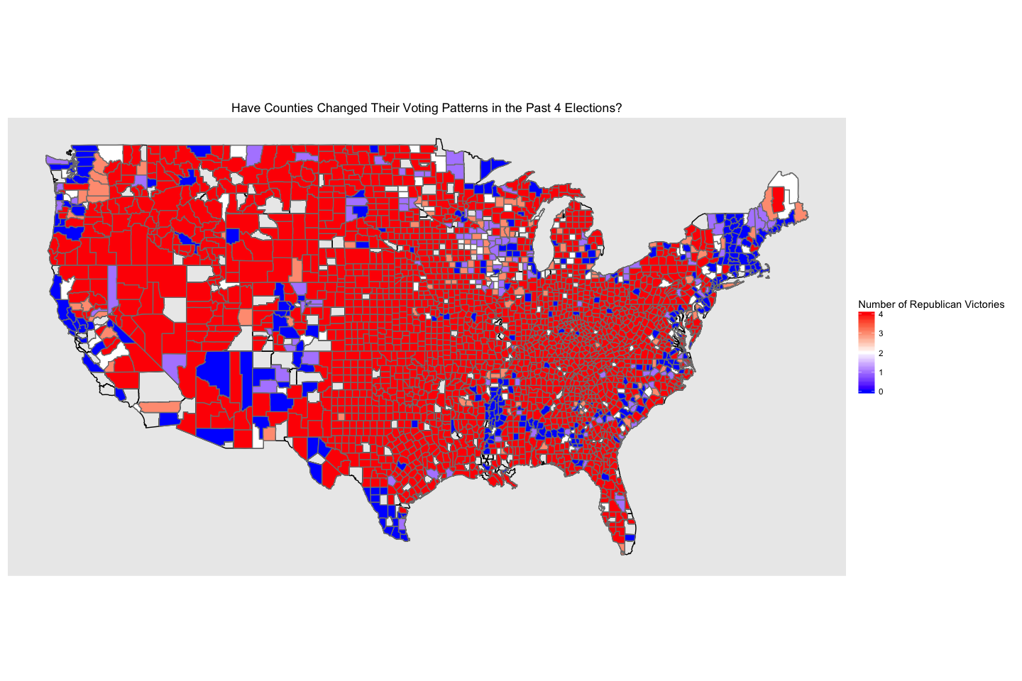

Does Education have an effect on how people vote?

eDFeducation=eDFmap  
eDFeducation$college=eDF1[c(-519:-522), "PerBachelor"]  
eDFeducation$mergeID=eDF1[c(-519:-522), "mergeID"]  
eDFeducationmerged=inner_join(countiesmap, eDFeducation, by.="mergeID")

## Joining, by = "mergeID"

## Warning in inner_join_impl(x, y, by$x, by$y, suffix$x, suffix$y): joining  
## character vector and factor, coercing into character vector

ggplot(data=eDFeducationmerged, aes(x=college, y=propRep_2016))+  
 geom_point()+  
 geom_hline(yintercept=0.5)+  
 geom_smooth(method="lm")+  
 scale_x_continuous("Percent of Population with Bachelor's Degree")+  
 scale_y_continuous("Percent of Republican Voters in 2016")+  
 ggtitle("Does Education Affect Political Affiliation?")

## Warning: Removed 67 rows containing non-finite values (stat_smooth).

## Warning: Removed 67 rows containing missing values (geom_point).

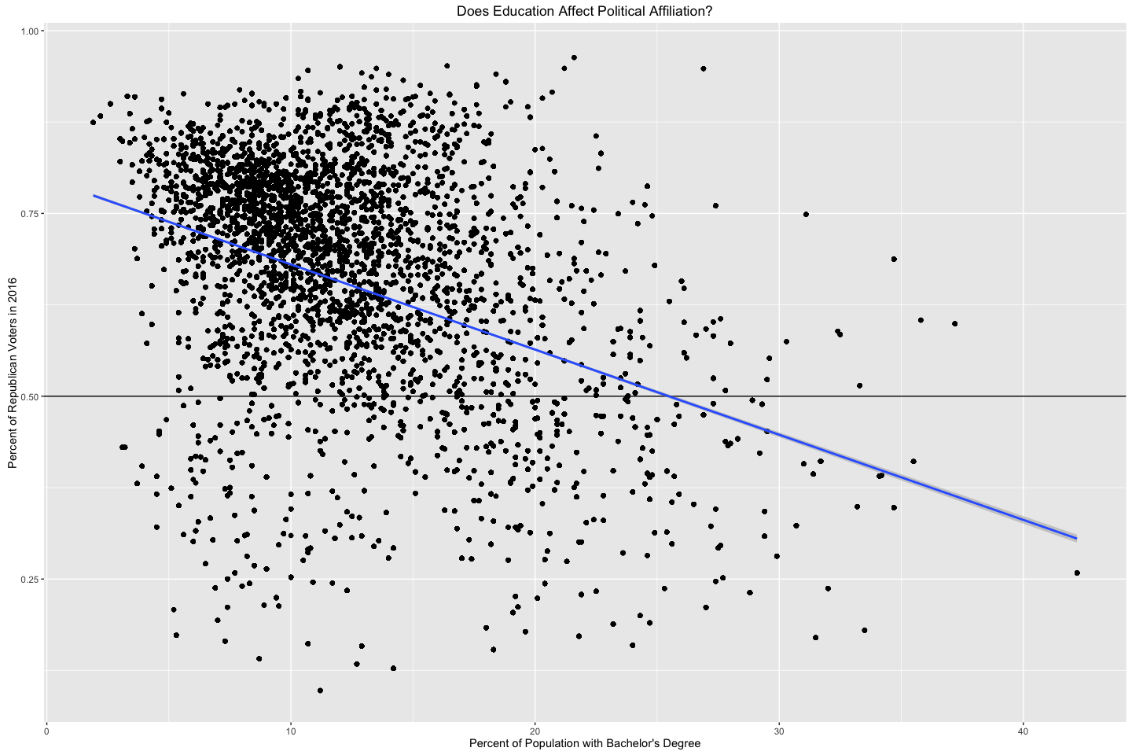

#this graph indicates that counties with a smaller percentage of population with Bachelor's degree will have more Republican voters  
  
counties_base+  
 geom_polygon(data = eDFeducationmerged, aes(x=long, y=lat, group=group, fill=college, colour=propRep_2016), size=0.75)+  
scale_fill_gradient("Percent with Bachelor's Degree",low="grey", high="black")+  
 scale_color_gradientn("Proportion of Republican Voters in 2016", colors=c("blue", "white", "red"))+  
 ggtitle("Does Education Affect Political Affiliation?")+  
 blanktheme+  
 coord_fixed(1.3)

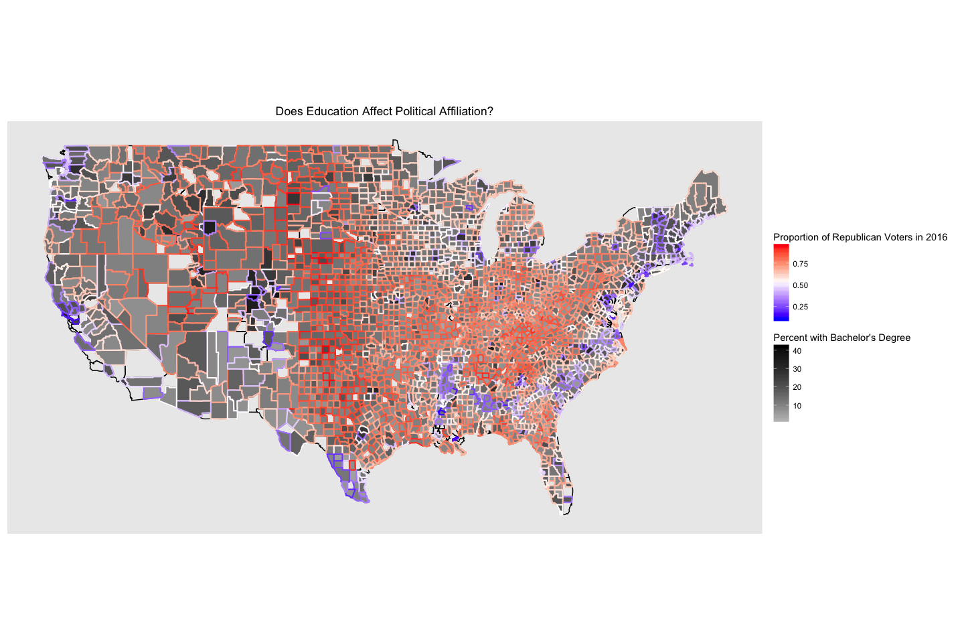

#it's hard to see much on a national level so let's focus on some specific states. I chose Michigan, Wisconsin, and Minnesota since they were extremely close states in this past election. The fact that these states have a mix of college towns and rural areas made them good candidates for this comparison as well.  
  
subset=eDFeducationmerged[eDFeducationmerged$region %in% c("michigan", "wisconsin", "minnesota"),]  
counties_base2=ggplot(data=subset,aes(x=long, y=lat, group=group))+geom_polygon(colour="black", fill=NA)  
  
counties_base2+  
geom_polygon(aes(fill=college), colour="white")+  
geom_point(data=subset, (aes(x=longitude, y=latitude, group=NA, colour=propRep_2016)), size=5)+  
scale_color_gradientn("Proportion of Republican Voters", colours=c("blue", "white", "red"))+  
 scale_fill_gradient("Percent with Bachelor's Degree", low="grey", high="black")+  
 ggtitle("Does Education Affect Political Affiliation?")+  
 blanktheme+  
 coord_fixed(1.3)

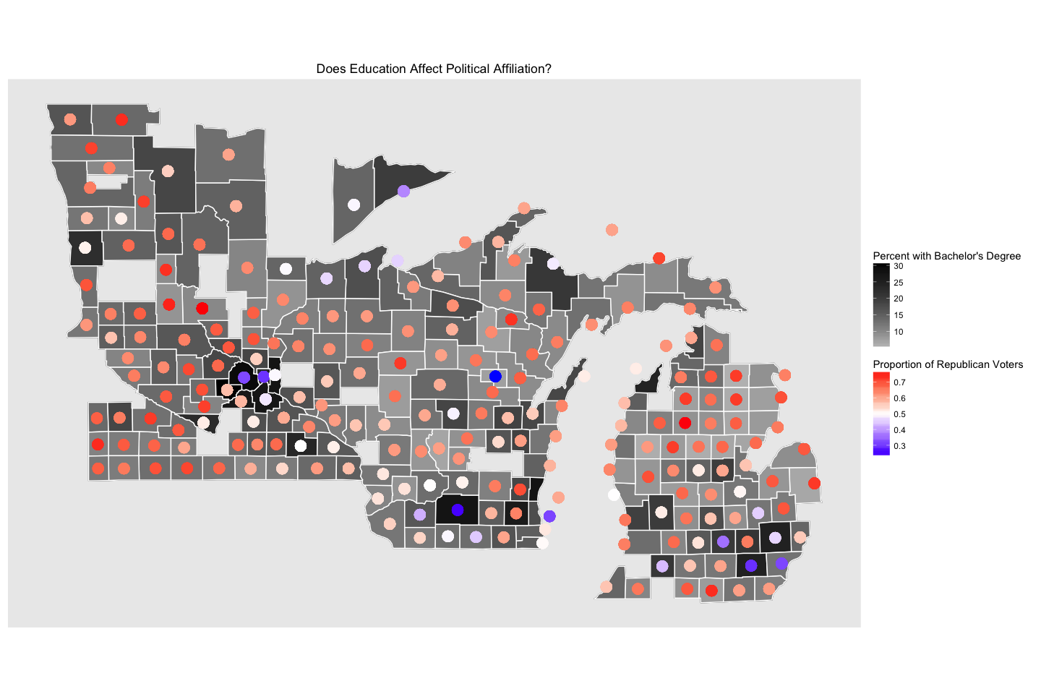

## Predicting 2016 Election result using K-NN (by Wei-Hsin (Philip) Lin and Yang Yang)

This is prediction of 2016 Election result uses K-NN method.

To obtain the training and testing data sets, we use the following algorithm:

1. For each county, we look at its voting records for Elections 2012, 2008, and 2004. If such county voted in favor of Republican at least twice out of the three elections, then we label it as Republican (rep), otherwise it is labeled as Democrat (dem). With such manner, we classify all counties as either "rep" or "dem". This is data set to be used.
2. This data set is divided into training data and testing data by the following manner: For each state, 2/3 of its counties will be randomly assigned to training data, and the rest 1/3 go to testing data. Therefore, 2/3 of the whole data set will be assigned to training data, and 1/3 will be assigned to testing data. For the training data, we further divide it in to two halves: for each state, one half of its counties are randomly chosen to trainging set 1, and the rest of the counties in that state go to training set 2. At the end of such data partition, we will have training set 1, training set 2 and testing. Each of them will have approximately 1/3 of the original data.
3. We use training set 1 and training set 2 as Two-fold Cross Validation to obtain a predictor with the best K value. Then the whole data set that generated at Step 1 is used as training data set, to predict Election 2016 at county level.

### Data Preparation

Firstly we make a subset of the final merged data frame "eDF" since not all the variables in the it will be used. Particularly, We are interested in logitude, latitude, all counties, states, number of votes for Republican and Democrat over the most recent your election. Also want to normalize the number of votes by converting it to rate of votes, so comparison is easier to make visually.

#Drop Hawaii, Alaska and census data.   
eDFNew = eDF[-c(68,519:522),1:12]  
  
#Calculate rate of vote for Elections 2012, 2008 and 2004  
eDFNew$repRate2012 = eDFNew$repVote2012 / (eDFNew$repVote2012 + eDFNew$demVote2012)  
eDFNew$demRate2012 = 1 - eDFNew$repRate2012  
eDFNew$repRate2008 = eDFNew$repVote2008 / (eDFNew$repVote2008 + eDFNew$demVote2008)  
eDFNew$demRate2008 = 1 - eDFNew$repRate2008  
eDFNew$repRate2004 = eDFNew$repVote2004 / (eDFNew$repVote2004 + eDFNew$demVote2004)  
eDFNew$demRate2004 = 1 - eDFNew$repRate2004

### Determine Winner over Year 2004, 2008, and 2012

Then we figure out the winner and loser at county level by checking the voting records over Election 2012, 2008 and 2004. For each county, if it votes at least twice for Republican, then it is classied as "rep", otherwise, labeled as "dem". With such manner, we lable all counties as either "rep" or "dem".

#Determine winner at county level; 1 indicates rep wins, 0 indicates dem wins  
result2016 = as.numeric(eDFNew$repVote2016 > eDFNew$demVote2016)  
result2012 = as.numeric(eDFNew$repVote2012 > eDFNew$demVote2012)  
result2008 = as.numeric(eDFNew$repVote2008 > eDFNew$demVote2008)  
result2004 = as.numeric(eDFNew$repVote2004 > eDFNew$demVote2004)  
  
#Change the dem's indicator from 0 to -1  
result2016[result2012 == 0] = -1  
result2012[result2012 == 0] = -1  
result2008[result2008 == 0] = -1  
result2004[result2004 == 0] = -1  
  
#Combine three Election results into a data frame  
result = data.frame(result2012, result2008, result2004)  
  
#Label each county as either "rep" or "dem" based on their voting record over three Elections  
sumresult = rowSums(result)   
eDFNew$winner = sapply(sumresult, function(x) ifelse(x > 0, "rep", "dem"))

### Preliminary Map

At this stage, we make a preliminary map to see if such rep/dem classification is reasonable.

#Make a preliminary map  
library(ggplot2)  
  
mapstate = map_data("state")  
  
plot1 <- ggplot() +   
 geom_polygon(data = mapstate, aes(x = long, y = lat,group = group),   
 colour = "grey50", fill = "white") +   
 geom_point(data = eDFNew, aes(x = longitude, y = latitude,   
 colour = factor(eDFNew$winner,   
 levels = c("rep", "dem"))), size = 0.3) +   
 labs(title = "Winner at county level", color = "Winner")  
  
plot1

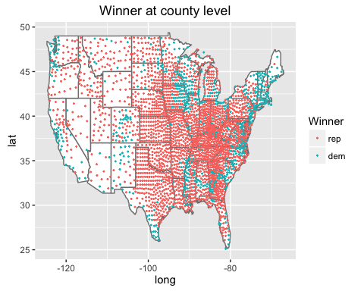

This map plots the winner at county level. The red points represents those counties that votes in favor of Republican, and the blue points represent Democrat's victories. Blue concentration occur alongside the East and West coast, and a vast majority of red points is observed in the middle of the US map. Since a traditional political map also has such victory distribution, such classification makes sense.

### Predictor Building Using K-NN Method

After the classification for each county, we divide these counties into three subsets: two training set call "training 1" and "training 2" repectively, and one testing set calles "testing". A county in a particular state has euqal probabilty to go to any one of these three subsets.

#Randomly generate 2 training sets and 1 testing set  
  
#Obtain unique state names  
state <- as.character(unique(eDFNew$state2016))  
  
#Count the number of county in Alabama  
index <- which(eDFNew$state2016 == state[1])  
  
#Randomly assign all counties in Alabam to training1, training2 or testing  
set.seed(1205)  
sample <- sample(index, replace = FALSE, size = length(index))  
training1 <- eDFNew[sample[1:floor(length(index)/3)], ]  
training2 <- eDFNew[sample[(floor(length(index)/3) + 1):floor(2*length(index)/3)], ]  
testing <- eDFNew[sample[(floor(2*length(index)/3) + 1):length(index)], ]  
  
#For the rest of the state, Randomly assign their counties to training1, training2 or testing.   
for (i in 2:length(state)) {  
 index <- which(eDFNew$state2016 == state[i])  
   
 set.seed(1205)  
 sample <- sample(index, replace = FALSE, size = length(index))  
 training1_temp <- eDFNew[sample[1:floor(length(index)/3)], ]  
 training2_temp <- eDFNew[sample[(floor(length(index)/3) + 1):floor(2*length(index)/3)], ]  
 testing_temp <- eDFNew[sample[(floor(2*length(index)/3) + 1):length(index)], ]  
   
 training1 <- rbind(training1, training1_temp)  
 training2 <- rbind(training2, training2_temp)  
 testing <- rbind(testing, testing_temp)  
}

This procedure produces 3 subset of the original data: training1, training2 and testing.

With the training and testing data set ready, we can now use K-NN method to train the data and predict 2016 Election result. For each county, we look for its nearest k neighbor and determine the winner of the county by simple majority votes: if more than a half of the k neightbor counties vote for Republican, then the county's winner is also Republican, and vice versa. We also find the best k value by using two-fold Cross Validation on training1 and training2. To find the best k, we test 100 values ranging from 1 to 100.

#Use Cross Validation and K-NN to train data and find best k value.  
library(class)  
  
#Prepare the true value of training data set to be comapared against  
training1Label = training1$winner  
training2Label = training2$winner  
trainingLabel = c(training1Label, training2Label)  
  
#Test 100 k values ranging from 1 to 100  
errorRate = vector(length = 100)  
for (i in 1:100){  
 pred1 = knn(train = training1[, c(11, 12)], test = training2[, c(11, 12)],   
 cl = training1Label, k=i)  
 pred2 = knn(train = training2[, c(11, 12)], test = training1[, c(11, 12)],   
 cl = training2Label, k=i)  
 pred = c(as.character(pred2), as.character(pred1))  
 compare = pred == trainingLabel  
 errorRate[i] = 1 - sum(compare) / length(compare)  
}

We choose the best k by comparing error rates, which are associated with each of the k. Here we make a plot to see how the error rate behaves as k grows from 1 to 100.

library(ggplot2)  
  
errorDF = data.frame(kvalue = c(1:100), errorRate)  
  
plot2 <- ggplot() +   
 geom_line(data = errorDF, aes(x = kvalue, y = errorRate)) +   
 labs(title = "Error Rates for different k values")  
plot2

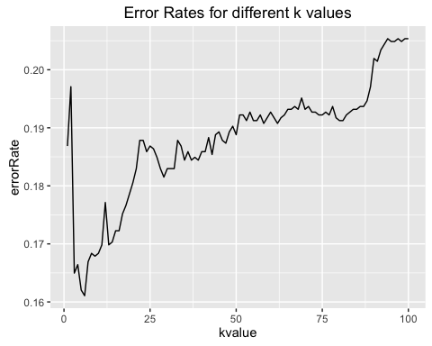

#Choose the best k value  
bestk = errorDF$kvalue[which(errorDF$errorRate == min(errorDF$errorRate))] - 1

As it can be seen from the graph, the rate has a sharp and short increase at the beginning and the decreases to hit the lowest at around k = 5. After that it increases rapidly. Although the min function tells us the lowest rate occur at k = 5, we choose a nearby value (k = 4)to avoid bias.

How well does the best k work? To test it validity, we use training1 and training2 as a whole training set to predict the "testing" set, which we have set aside so far.

#Using the training data set 1 and training data set 2 as a whole to predict the testing data set  
training = rbind(training1, training2)  
testingLabel = testing$winner  
  
predTest = knn(train = training[, c(11, 12)], test = testing[, c(11, 12)], cl = trainingLabel, k = bestk)  
comapre = predTest == testingLabel  
errorRate_testing = 1 - sum(compare) / length(compare)  
#errorRate_testing = 0.2053528

The error rate is 0.2053528, which is acceptable given the size of training set and testing set.

### Prediction for 2016 Election

With the best k value at hand, it is now time to predict the 2016 Election result. The training set for such prediction is still the combination of training1 and traing2, but the testing set is all the counties in US mainland.

#Predict 2016 Election result  
  
#This is the true election result  
trueWinner2016 = sapply(result2016, function(x) ifelse(x > 0, "rep", "dem"))  
  
#Make prediction for 2016election  
predTest = knn(train = training[, c(11, 12)], test = eDFNew[, c(11,12)], cl = trainingLabel, k = bestk)  
  
#Make comparison  
compare = as.character(predTest) == trueWinner2016  
errorRate2016 = 1 - sum(compare) / length(compare)#The error rate is about 0.1  
#errorRate2016 = 0.1276596

The error rate for 2016 Election result prediction is about 0.1277, which is sustantially less the the error rate (about 0.2054) produced by predicting the testing data set. The reason behind such a drop in error rate is as follows: At the first prediction, the training set contains 2000 counties, and the testing set contains the rest 1000 counties. At the second prediction, the training set stays the same, but the training set expands to all 3000 counties, which means 2000 counties of the testing set are exactly the sames as the training set. Therefore the training data also predict itself, which increase the accuracy of prediction.

### 2016 Predicted Result v.s. 2016 Election Result

Finally we want to make two maps to make a visual comparison.

library(ggplot2)  
#Create a data frame containing longitude, latitude, prediction and true result  
dfResult2016 = data.frame(eDFNew$longitude, eDFNew$latitude, predTest, trueWinner2016)  
names(dfResult2016)[c(1,2)] = c("longitude", "latitude")  
  
#Map for predicted result  
plot3 <- ggplot() +   
 geom_polygon(data = mapstate,   
 aes(x = long, y = lat, group = group), colour = "grey50", fill = "white") +   
 geom_point(data = dfResult2016,   
 aes(x = longitude, y = latitude,   
 colour = factor(dfResult2016$predTest,   
 levels = c("rep", "dem"))), size = 0.3) +   
 labs(title = "Predicted Winner at county level", color = "Winner")  
plot3

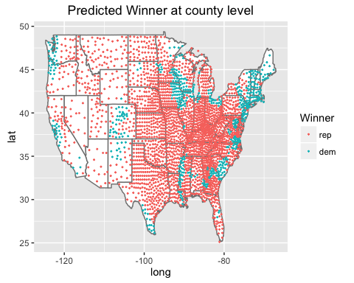

#Map for true result  
plot4 <- ggplot() +   
 geom_polygon(data = mapstate, aes(x = long, y = lat, group = group),   
 colour = "grey50", fill = "white") +   
 geom_point(data = dfResult2016, aes(x = longitude, y = latitude,   
 colour = factor(dfResult2016$trueWinner2016,   
 levels = c("rep", "dem"))), size = 0.3) +   
 labs(title = "True Winner at county level", color = "Winner")   
plot4

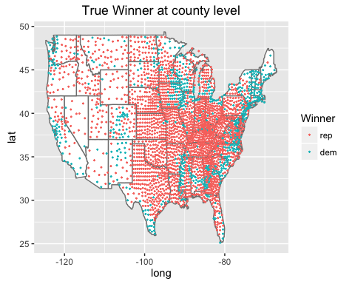

Both maps shows similar plotting pattern: red concentration in the middle occupies most of the US map with blue concentration occurs alongside East and West coasts, and the Great Lakes area. Note that it's hard to see which counties fail the prediction. Therefore, the map below shows the exact locations that the predtions failed.

library(ggplot2)  
eDFpred <- data.frame(result = eDFNew$winner,predResult = predTest, error = compare, eDFNew[, 11:12])  
plot5 <- ggplot(eDFpred[eDFpred$error == FALSE, ]) +   
 geom_polygon(data = mapstate, aes(x = long, y = lat, group = group),   
 colour = "grey50", fill = "white") +   
 geom_point(mapping = aes(x = longitude, y = latitude), size = 0.3, color = "forestgreen")  
plot5

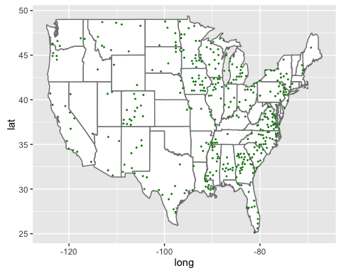

### Summary

K-NN is a simple but also accurate statistical method when it is used to predict the election result. By the mechanism of simple majority vote, K-NN predicts all the winner at county level with an error rate of 0.1277. Part of such low rate is made possible by the classification of all counties at the beginning of the prediction. Rather than using only a particular year's election result to train the data, we examine 3 election results and label each county as "rep" or "dem" accordingly. This makes our data set more reliable because the records of 3 consecutive years more or less reveal each county's preference. The drawback of this prediction is that the error rate is a little bit high when predicting the testing data set by two-fold Cross Validation. However, the error rate is expected to decrease if we increase the folds. In conclusion, the winner of Election 2016 is not a surprise at all, given that even such a simple project can predict the winner (at county level) with an error rate of 0.1277.

## Predicting Change in Election Results (2012 - 2016) (by Tien & Zhi Chao)

In this section, we build a prediction model for the change in election results from 2012 to 2016, and this is carried out in three parts - (i) Construction of a dataframe containing the predictor variables required for the analysis; (ii) Construction and validation of the prediction model; and (iii) analysis of the prediction results. The remaining of the section is structured as such: First a short description of each part will be provided, and comments in the subsequent code chunk will detail the exact steps carried out in the code.

### Part 1: Constructing the Dataframe

For the first part, we start by constructing a "changeID" columns denoting the actual change from 2012 to 2016, with the values of (1,2,3,4) representing counties that (stayedRep, stayedDem, wentRep, wentDem) respectively. Next, we use only county census data as our predictors, preparing the dataframe for subsequent prediction (eg dropping rows with NAs and converting columns into numeric classes)

library(rpart)  
library(ggplot2)  
library(dplyr)  
library(rpart.plot)  
  
## Defining a function to create changeID from the 2012 & 2016 voting results  
  
createChangeID = function(voteResults) {  
   
 repVote2016 = voteResults[[1]]  
 demVote2016 = voteResults[[2]]  
 repVote2012 = voteResults[[3]]  
 demVote2012 = voteResults[[4]]  
   
 changeID = repVote2016  
 repWin2016 = (repVote2016 >= demVote2016)  
 repWin2012 = (repVote2012 >= demVote2012)  
   
 stayedRep = (repWin2016 & repWin2012)  
 stayedDem = (!repWin2016 & !repWin2012)  
 wentRep = (!repWin2012 & repWin2016)  
 wentDem = (repWin2012 & !repWin2016)  
   
 changeID[stayedRep] = 1  
 changeID[stayedDem] = 2  
 changeID[wentRep] = 3  
 changeID[wentDem] = 4  
   
 return (changeID)  
}  
  
  
## Preparing the DataFrame for Prediction  
  
# Change "percentage unmarried women" from character to numeric  
# Subset selected columns for census data  
# Remove rows with NA values  
# Create the changeID  
  
eDF[,23]= as.numeric(eDF[,23])

## Warning: NAs introduced by coercion

changeDF = eDF[, c(1:6,11:45)]  
changeDF = changeDF[apply(is.na(changeDF), 1, sum) == 0,]  
changeDF["changeID"] = createChangeID(changeDF[,3:6])  
changeDF = changeDF[,c(1:2,7:8,42, 9:41)]

### Part 2: Constructing the Model

For the second part, we construct a classification tree model with our prepared predictors and tune its complexity parameter with hold-out validation before testing the model on a final test set. To do so, we first partition out data randomly into a test set (20%), a validation set (20%), and a training set (60%). Next, we use the training set to train our model across various complexity parameters, graphically selecting the parameter value that performed the best on the validation set (in terms of prediction accuracy). Finally, we train the model with the selected complexity parameter on bothe the training and validation set, and evaluate its performance on the original test set to see its final effectiveness. Below, we find that the final performance of our model is 87 percent, which is rather satisfactory.

## Create the test, validation, and training set  
  
# Test, validation, and training set have 20%, 20%, and 60% of the data each  
# Seed is set to ensure reproducibility of data  
  
set.seed(123456789)  
nRowsTotal = nrow(changeDF)  
chooseTandV = sample(nRowsTotal, size = nRowsTotal*0.4, replace = FALSE)  
changeTandV = changeDF[-chooseTandV,]  
nRowsTandV = nrow(changeTandV)  
chooseTest = sample(nRowsTandV, size = nRowsTandV*0.5, replace = FALSE)  
  
changeTest = changeTandV[chooseTest,]  
changeVal = changeTandV[-chooseTest,]  
changeTrain = changeDF[-chooseTandV,]  
  
nRowsTest = nrow(changeTest)  
nRowsVal = nrow(changeVal)  
nRowsTrain = nrow(changeTrain)  
  
  
## Building the Classification Tree Model  
  
# Create a list of potential complexity parameters  
# Training a model for each complexity value  
  
cmplxParamList = c(seq(0.0001, 0.001, by = 0.0002),   
 seq(0.001, 0.01, by = 0.002),  
 seq(0.01, 0.1, by = 0.02))  
  
modelPred = matrix(nrow = nRowsVal, ncol = length(cmplxParamList))  
  
for (i in 1:length(cmplxParamList)) {  
 modelTree = rpart(changeID ~ ., data = changeTrain[,5:38], method = "class",   
 control = rpart.control(cp = cmplxParamList[i]))  
 modelPred[, i] = predict(modelTree, newdata = changeVal[,5:38], type = "class")  
}  
  
# Choose the model with the highest prediction accuracy ()  
  
modelPredAcc = apply(modelPred == changeVal$changeID, 2, sum)  
modelPredAcc = modelPredAcc/nRowsVal  
modelPredAccDF = data.frame(complexity = cmplxParamList, accuracy = modelPredAcc)  
modelPredAccPlot = ggplot(data = modelPredAccDF, aes(x = complexity, y = accuracy)) +  
 geom_line() + labs(x = "Complexity", y = "Accuracy")  
modelPredAccPlot

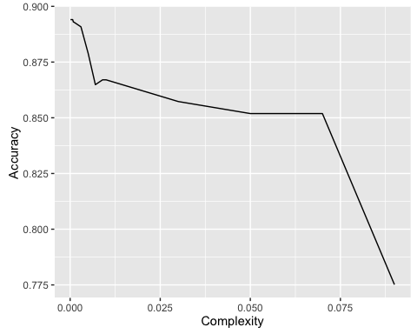

# Testing the model on the test set  
# By visual inspection we choose complexity parameter 0.001 with 0.8946 accuracy  
# Final prediction accuracy is shown at around 87 percent  
  
changeTrainAll = rbind(changeTrain, changeVal)  
nRowsTrainAll = nrow(changeTrainAll)  
modelTreeF = rpart(changeID ~ ., data = changeTrainAll[,5:38], method = "class",   
 control = rpart.control(cp = cmplxParamList[6]))  
modelPredF = predict(modelTreeF, newdata = changeTest[,5:38], type = "class")  
modelPredAccF = sum(modelPredF == changeTest$changeID)/nRowsTest  
modelPredAccF

## [1] 0.8658009

### Part 3: Analysing the Results

In the third part, we analyse the results of our prediction model over and beyond just its final prediction accuracy. First, the classification tree is plotted to give a rough idea of the branches in the decision process.

## Plotting the classification tree   
  
# The original tree has been trimmed as it is too complicated  
# Complexity parameter has been set at 0.008  
  
modelTreeFPlot = prune(modelTreeF, cp=0.008)  
prp(modelTreeFPlot, extra =2)

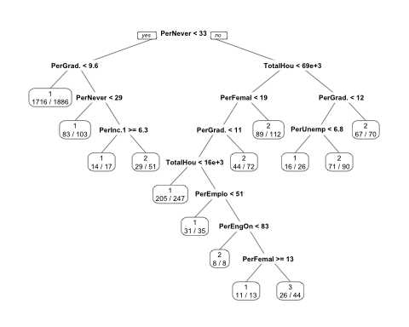

Next, the accuracies for each state are tallied and shown. It should be noted that most of the states are predicted accurately 75 percent and above. Additionally, some states such as Vermont and Maine have around 50 percent accurate because they have less number of counties, which affects the ratio for the value of percentage.

## Prediction accuracy is analyzed for each state individually  
  
# The model is now trained on all of the data  
# It is used to predict results from every state  
# The percentage of correctly predicted counties in each state is computed  
# States with the highest prediction inaccuracy are shown below  
  
modelPredFAll = predict(modelTreeF, newdata = changeDF[,5:38], type = "class")  
  
changeDFPred = data.frame(state = changeDF$state2016, county = changeDF$county2016,  
 changeID = changeDF$changeID, changeIDPred =modelPredFAll,  
 predCorrect = (changeDF$changeID == modelPredFAll),   
 longitude = changeDF$longitude, latitude = changeDF$latitude)  
  
statesCNo = aggregate(changeDFPred$predCorrect, list(state = changeDFPred$state), sum)  
statesTNo = aggregate(changeDFPred$predCorrect, list(state = changeDFPred$state), length)  
statesCNo$x = statesCNo$x*100  
statesCPer = data.frame(state = statesCNo$state, percentage = statesCNo$x/statesTNo$x, noCounties = statesTNo$x)  
statesCPer = arrange(statesCPer, percentage, noCounties)  
head(statesCPer,15)

## state percentage noCounties  
## 1 vermont 50.00000 14  
## 2 maine 50.00000 16  
## 3 rhodeisland 60.00000 5  
## 4 newhampshire 60.00000 10  
## 5 newmexico 61.29032 31  
## 6 washington 61.53846 39  
## 7 newyork 66.12903 62  
## 8 delaware 66.66667 3  
## 9 southdakota 71.87500 64  
## 10 iowa 72.72727 99  
## 11 arizona 73.33333 15  
## 12 hawaii 75.00000 4  
## 13 wisconsin 75.00000 72  
## 14 southcarolina 76.08696 46  
## 15 colorado 77.41935 62

Fnally, we plot on the map counties which had the wrong predictions to visualize spatially where the predictions were wrong for. This map is shown below.

## Make a plot of the counties with the wrong predictions  
  
# Drop hawaii to facilitate map plotting  
  
changeDFPred = changeDFPred[changeDFPred$state != "hawaii", ]  
  
accPlot = ggplot(changeDFPred[changeDFPred$predCorrect == FALSE,]) +   
 geom_polygon(data = mapstate, aes(x = long, y = lat, group = group),   
 colour = "grey50", fill = "white") +   
 geom_point(mapping = aes(x = longitude, y = latitude), size = 1, color = "red") + ggtitle("Wrong Prediction Locations")  
accPlot

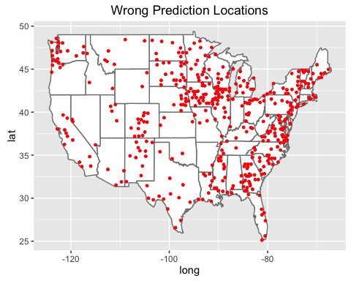

## Comparison of Two Predictors

We investigate the errors further by checking where they occur. Firstly we plot all the counties that fail in the two prediction model. As it can be seen from the map, blue points represent the errors that produced only by the regression tree model, green points represent the errors that produced only by the K-NN model, and red points are the common errors that arise from both models. While red errors are significantly less than the blue and green ones, all three kind of errors appear mostly along the Great Lake area and the East coast, which means these areas are not easy to predict by regression tree and K-NN. This is so because most of these failed counties are in the swing states. For example, we can see large concentrations of in Wisconsin, Michigan, North Caroline and Florida, all of which are considered battlegrounds for Republicans and Democrats. Counties in swing states are more difficult to predict than those in solid red or solid blue state, because different political ideologies advocated by Republicans and Democrats have similarly amount of supporters. Therefore, it is no surprising that prediction models are more likely to fail in those swing counties.

dfMap = merge(eDFpred, changeDFPred, by = "longitude")  
dfMap = dfMap[,c(6,7,4,10,1,5)]  
dfMap$acc = NA  
dfMap$acc[dfMap$error == FALSE & dfMap$predCorrect == FALSE] = 1  
dfMap$acc[dfMap$error == FALSE & dfMap$predCorrect == TRUE] = 2  
dfMap$acc[dfMap$error == TRUE & dfMap$predCorrect == FALSE] = 3  
dfMap = dfMap[!is.na(dfMap$acc), ]  
dfMap$acc = factor(dfMap$acc, levels = c(1,2,3), labels = c("Both Models Wrong", "2016 Wrong", "Change 12-16 Wrong"))  
  
ggplot() +   
 geom_polygon(data = mapstate, aes(x = long, y = lat, group = group),   
 colour = "grey50", fill = "white") +   
 geom_point(data = dfMap,   
 mapping = aes(x = longitude, y = latitude.x, color = acc), size = 1) +   
 labs(title = "Comparision of Failed Prediction Locations",   
 color = "Error")

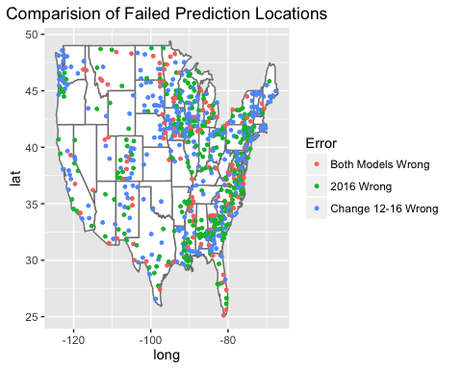

## References:

### Language Uses:

R

### Packages Use:

readr, XML, readxl, RCurl, dplyr, ggplot2, class, rpart

### Data Sources:

2016 Presidential Election results reported at the county level. These are available at <http://www.stat.berkeley.edu/users/nolan/data/voteProject/2016_US_County_Level_Presidential_Results.csv> The original data are from github account at <https://github.com/tonmcg/County_Level_Election_Results_12-16/blob/master/2016_US_County_Level_Presidential_Results.csv>

2012 Presidential Election results reported at the county level. The original data are available from <http://www.politico.com/2012-election/map/#/President/2012/> These data are available at <http://www.stat.berkeley.edu/users/nolan/data/voteProject/countyVotes2012/xxx>. xml Where xxx stands for state names. e.g. <http://www.stat.berkeley.edu/users/nolan/data/voteProject/countyVotes2012/alabama.xml>

2008 Presidential Election results (county level) are available from The Guardian in a Google Sheet at <https://www.theguardian.com/news/datablog/2009/mar/02/us-elections-2008> This sheet has been uploaded as an xlsx spreadsheet at <http://www.stat.berkeley.edu/users/nolan/data/voteProject/countyVotes2008.xlsx>

2004 Presidential Election results (county level) without Virginia are available at <http://www.stat.berkeley.edu/users/nolan/data/voteProject/countyVotes2004.txt> 2004 Election Data for Virginia is available at <https://en.wikipedia.org/wiki/United_States_presidential_election_in_Virginia,_2004>

Census data from the 2010 census available at <http://factfinder2.census.gov/faces/nav/jsf/pages/searchresults.xhtml?refresh=t> Data available at <http://www.stat.berkeley.edu/users/nolan/data/voteProject/census2010/B01003.csv> <http://www.stat.berkeley.edu/users/nolan/data/voteProject/census2010/DP02.csv> <http://www.stat.berkeley.edu/users/nolan/data/voteProject/census2010/DP03.csv> <http://www.stat.berkeley.edu/users/nolan/data/voteProject/census2010/B01_metadata.txt> <http://www.stat.berkeley.edu/users/nolan/data/voteProject/census2010/DP02_metadata.txt> <http://www.stat.berkeley.edu/users/nolan/data/voteProject/census2010/DP03_metadata.txt>

GML (Geographic Markup Language) data that contains the latitude and longitude for each county. These are available at <http://www.stat.berkeley.edu/users/nolan/data/voteProject/counties.gml>

### Sources used to clean data:

In 2016 data, state names were given in abbreviations. The comparison table is available at  
<http://www.fonz.net/blog/wp-content/uploads/2008/04/states.csv>

Figure out Dade County in Florida is also known as Miami-Dade County <http://miamidade.gov/>

Oglala Lakota County, known as Shannon County until May 2015, is a county located in the U.S. state of South Dakota. <https://en.wikipedia.org/wiki/Oglala_Lakota_County,_South_Dakota>

Figure out counties names may be called as different names in New York Five boroughs of New York City. Five of New York's counties are each coextensive with New York City's five boroughs and do not have county governments. They are: New York County (Manhattan), Kings County (Brooklyn), Bronx County (The Bronx), Richmond County (Staten Island), and Queens County (Queens). <https://en.wikipedia.org/wiki/List_of_counties_in_New_York>

The location coordinates of Broomfield County in Colorado is found at <http://www.latlong.net/place/broomfield-co-usa-3794.html>

The 2008 Election result for District of Columnbia is found at <https://en.wikipedia.org/wiki/United_States_presidential_election_in_the_District_of_Columbia,_2008>

## Contribution:

Wei-Hsin (Philip) Lin: 2008, Predicting 2016 Election result using K-NN

Yang Yang: 2012, Predicting 2016 Election result using K-NN

Zhi Chao Poh: 2004, Predicting Change in Election Results (2012 - 2016)

Tien Nguyen: 2010 (Census Data), Predicting Change in Election Results (2012 - 2016)

Jinjin Tang: 2016, EDA and Maps Making

Altogether: the rest